GramVeda

Mini Project Report

Submitted in partial fulfilment of the requirement of the degree of

Master of Computer Application

to

K.R Mangalam University

by

Aman (2401560044)

Mohini (2401560053)

Daksh (2401560058)

Nibha (2401560077)

Under the supervision of

# Ashwini Sir

# Frontend Developer



Department of Computer Science and Engineering

School of Engineering and Technology

K.R Mangalam University, Gurugram- 122001, India

April 2025

CERTIFICATE

This is to certify that the Project Synopsis entitled, “GramVeda” submitted by “Aman (2401560044) Mohini(2401560053) Daksh(2401560053) Nibha(2401560077)” to K.R Mangalam University, Gurugram, India, is a record of bonafide project work carried out by them under my supervision and guidance and is worthy of consideration for the partial fulfilment of the degree of Master of Computer Application in Computer Science and Engineering of the University.

Signature Dean SOET

Dr Pankaj Agarwal, Dean SOET

Date: 30th April 2025

# Project Use Case & Deployment Confirmation Certificate

This is to formally acknowledge that the following student(s) from K.R. Mangalam University have successfully undertaken and completed an industry-based project under our mentorship, in alignment with the stated objectives and requirements of our organization.

Project Details:

* Project Title: GramVeda
* Domain/Technology Used: MERN Stack
* Industry Use Case / Business Problem Addressed:

GramVeda supports rural farmers by promoting organic farming, offering training, and enabling direct market access. It helps increase farmers' income through sustainable practices, value addition, and reduced middlemen, empowering communities with knowledge and better agricultural solutions.

* Expected Outcome/Utility of the Project in Our Organization:

"The project will enhance agricultural productivity, empower farmers with knowledge-driven solutions, and create a sustainable rural ecosystem, ultimately contributing to increased income, reduced dependency on middlemen, and strengthened community engagement."

Student Details:

Name of Student Enrollment No. Program Year

Aman (2401560044)

Mohini (2401560053)

Daksh (2401560058)

Nibha (2401560077)

2024-2026

## Introduction

1. **GramVeda** is a full-stack agritech platform developed to empower rural farmers by providing digital access to expert agricultural advice, crop management tools, and essential farming services. Built using the **MERN stack** (MongoDB, Express.js, React.js, and Node.js), the platform bridges the gap between traditional agriculture and modern technology.
2. The application features a responsive user interface developed using **React.js** and **Tailwind CSS**, along with a robust backend built with **Node.js** and **Express.js**. It enables farmers to create personalized profiles, consult agricultural experts, upload critical documents like soil reports and land records, and list produce for market access.
3. Key functionalities such as **JWT-based secure authentication**, **role-based access control** for Farmers, Experts, and Admins, and a **real-time appointment booking system** were implemented to ensure platform security, usability, and efficiency. A document upload and verification system was also developed to manage agricultural records and subsidy applications.
4. The development process involved version control using **Git and GitHub**, ensuring smooth collaboration and streamlined code management. GramVeda not only addresses key rural farming challenges but also sets the foundation for future advancements such as AI-driven crop diagnostics and multilingual support, enhancing agricultural outcomes and livelihoods in rural communities.

Learning Outcomes

## • Gained practical experience in developing a full-stack MERN application for solving real-world agritech challenges like crop advisory, expert booking, and document verification.

## • Enhanced skills in frontend/backend development, secure authentication, and role-based access control tailored to a rural farmer-centric platform.

|  |  |  |
| --- | --- | --- |
| 1. | Introduction (description of broad topic) | 04 |
| 2. | Abtract | 06 |
| 3. | Motivation | 08 |
| 4. | Literature Review/Comparative work evaluation | 09 |
| 5. | Gap Analysis | 10 |
| 6. | Problem Statement | 11 |
| 7. | Codes | 12,13 |
| 8. | Objectives | 14 |
| 9. | Methodology | 15 |
| 10. | Tools/platform Used | 16 |
| 11. | Experimental Setup | 17 |
| 12. | Implementation | 18 |
| 13. | Results And Discussion | 19 |
| 13. | Conclusion & Future Work | 20 |
| 14. | References | 21 |
| 15. | Annexure I: Plagiarism Report |  |

ABSTRACT

The MERN stack (MongoDB, Express, React, and Node.js) was used to develop the full-stack web application **GramVeda**, a digital platform designed to connect farmers with agricultural experts and services. One of the core features of GramVeda is its **crop advisory and expert consultation system**, allowing farmers to browse verified agricultural experts, view their profiles, and schedule consultations directly through the platform. This functionality streamlines access to timely, expert-driven advice, improving decision-making in farming activities.

In addition to expert consultations, GramVeda offers a **structured system for agricultural document management**. Users can upload documents such as soil reports, land records, and subsidy forms in formats like PDF and DOCX. These can be reviewed and verified by authorized agronomists or government advisors to ensure accuracy and compliance. The platform incorporates **version control** for tracking document changes and implements secure, role-based authentication for farmers, experts, and administrators. GramVeda improves collaboration, enhances agricultural workflows, and lays the groundwork for future integration of AI-powered crop and pest detection tools.

**KEYWORDS:** MERN Stack, GramVeda, Agritech, Crop Advisory, Document Management

## 1. Background of the project

In today’s fast-paced digital era, accessing timely legal assistance and efficiently managing legal documents remains a major challenge, especially for individuals and small businesses. Traditional legal services often involve lengthy paperwork, manual processes, in-person consultations, and scattered document storage. These issues can lead to delays, increased costs, and limited accessibility for those who need legal help the most.

The legal industry is currently lagging behind in offering user-centric, online solutions, despite the fact that many other businesses have quickly embraced digital change. The LegalEase project was designed to fill this gap by providing a centralised, safe, and userfriendly digital platform that is suited to contemporary legal requirements.

By allowing users to schedule appointments with solicitors, upload and maintain legal documents, and have them examined and validated by certified legal specialists, LegalEase seeks to close the gap between clients and legal professionals. To protect data privacy and expedite legal operations, the platform also adds secure authentication, version tracking, and role-based access controls. LegalEase improves transparency, encourages improved teamwork, and lowers the cost and increases the accessibility of legal services by digitising and streamlining these procedures.

The project not only addresses current challenges but also sets the stage for future enhancements such as AI-assisted legal analysis and multilingual support.

## 2. MOTIVATION

The motivation behind developing **GramVeda** arises from the significant digital divide in the agricultural sector, especially in rural India. While many industries have rapidly adopted technology to improve accessibility and efficiency, the farming community still depends heavily on traditional practices and manual processes. Small and marginal farmers often face challenges in accessing timely expert advice, managing essential agricultural documents, and benefiting from government schemes due to the lack of organized, tech-enabled support systems.

Additionally, the absence of centralized platforms for expert consultations and document management creates inefficiencies and communication gaps between farmers and agricultural advisors. Existing solutions are often outdated, difficult to navigate, or lack critical features such as expert verification, appointment scheduling, or secure document handling.

**GramVeda** was envisioned to solve these problems by providing a secure, user-friendly platform where farmers can connect with verified agricultural experts, book consultations, upload documents like soil reports or subsidy applications, and receive accurate guidance. Features such as expert-led document verification, version control, and role-based access for different users further strengthen its utility and reliability.

By integrating modern technology with agricultural expertise, **GramVeda** aims to make essential farming services more accessible, efficient, and affordable—particularly for underserved rural communities that often struggle with limited resources and information gaps.

LITERATURE REVIEW

## 1. Over the years, researchers and experts have highlighted the slow pace at which the agricultural sector—particularly in rural areas—has adopted digital technologies. While industries like finance, healthcare, and education have embraced digital transformation, many farming communities still rely on traditional, manual methods for decision-making, record-keeping, and expert consultation. This gap in digital integration often results in inefficiencies, limited access to expert advice, and underutilization of government resources and schemes.

## Some agritech platforms, such as Kisan Suvidha, AgriApp, and mKisan, have attempted to provide digital solutions through weather updates, market prices, and basic advisory services. However, many of these solutions lack real-time expert interaction, personalized crop guidance, or robust document management features. Additionally, critical functionalities like **role-based access control**, **document version tracking**, and **secure data storage** are often missing, which limits the reliability and effectiveness of these platforms in addressing the full scope of farmers’ needs.

## Studies also show that small and marginal farmers face significant barriers in accessing timely agricultural information due to low digital literacy, poor infrastructure, and lack of personalized support. Experts suggest that an ideal solution should be farmer-friendly, easily accessible, and capable of offering real-time guidance and secure document handling.

## This is where **GramVeda** stands out. By integrating features such as **expert consultations**, **document upload and verification**, **role-based access**, and **secure data management**, GramVeda addresses the gaps found in existing systems and aims to deliver a comprehensive, tech-enabled support system tailored to rural agricultural needs.

## 

## 2.GAP ANALYSIS

Despite growing efforts in digitizing agriculture, many farmers still face significant challenges in accessing expert advice and managing essential farming documents. While some agritech platforms exist, they usually focus on one or two features such as providing weather forecasts or general crop tips. These fragmented systems fail to deliver a complete and practical solution for farmers' day-to-day needs.

Here are the main gaps identified in current systems:

* Farmers can **access general agricultural content**, but often **cannot book consultations with certified experts** for personalized advice.
* Some platforms offer **basic information sharing**, but lack the functionality to **upload and verify important documents** like soil test reports or subsidy applications.
* There is **no centralized system** that combines expert booking, document upload, review, and personalized crop advisory in a single platform.
* Many tools are either **too complex** for farmers with limited digital literacy or **not affordable** for small and marginal farmers.
* Most platforms lack **secure document storage**, version control, and role-based access, making it hard for users to organize and retrieve important data when needed.

**GramVeda** was developed to address all these issues by offering a unified, farmer-friendly platform. It allows users to schedule expert consultations, upload documents, receive verified feedback, and securely manage their agricultural records — all from one accessible system.

**PROBLEM STATEMENT**

In the digital age, rural farmers continue to face difficulties in accessing timely agricultural expertise and managing key farming-related documents. Traditional systems still rely on **in-person interactions, manual paperwork**, and scattered processes that are inefficient and time-consuming. Existing digital solutions provide **either general advice without expert interaction**, or **document features without expert review or consultation booking**.

There is a clear need for an integrated, secure, and easy-to-use platform that enables farmers to:

* **Consult with verified agricultural experts online.**
* **Book appointments** based on real-time availability.
* **Upload and manage critical agricultural documents securely.**
* **Get documents reviewed and verified** by professionals for purposes like subsidy applications or certification.

**GramVeda** addresses this need by combining all essential features into one powerful platform tailored specifically for rural farming communities.

CODES:-

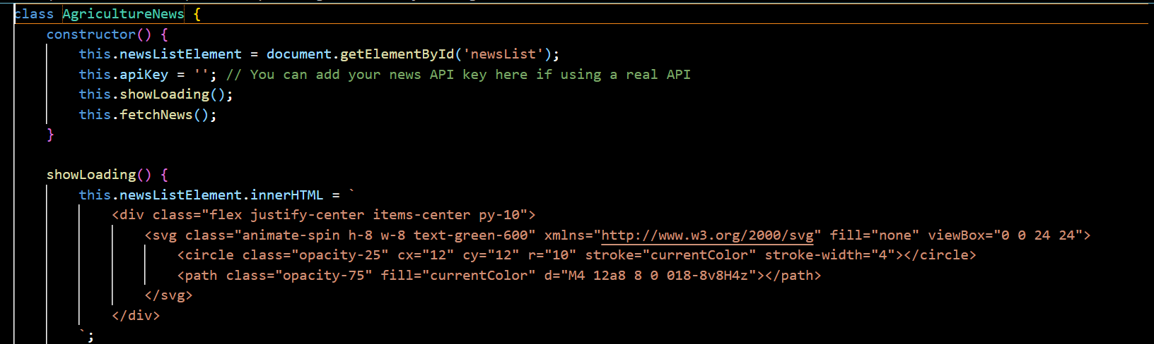Agriculture [News :-](News:-)

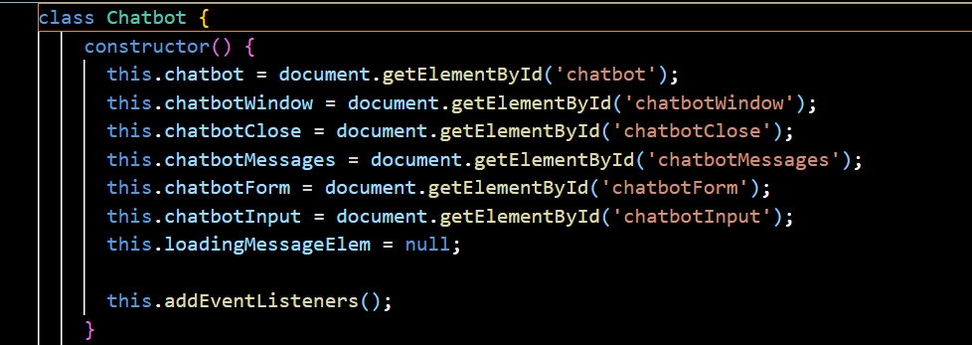Chatbot -Updated:-

Crop-Database:-

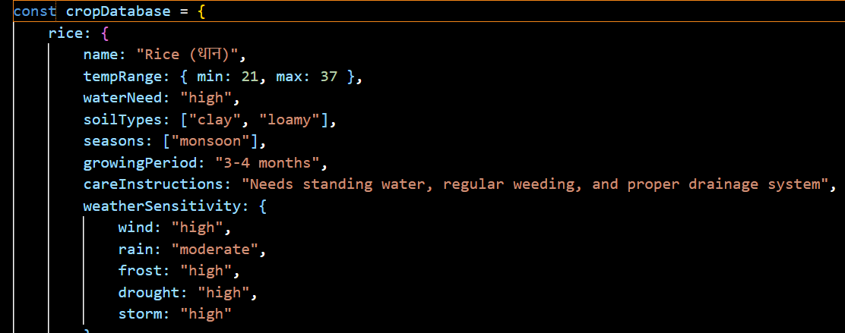

Main:-

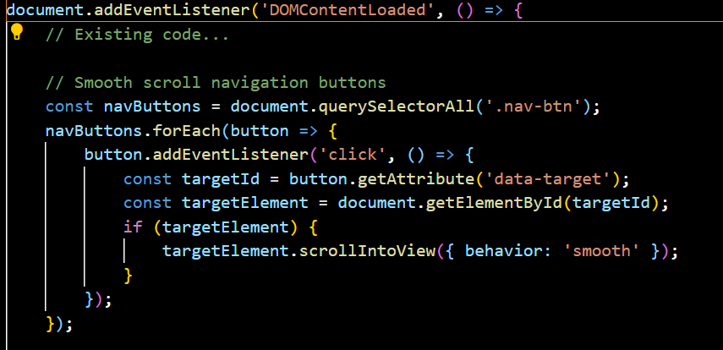

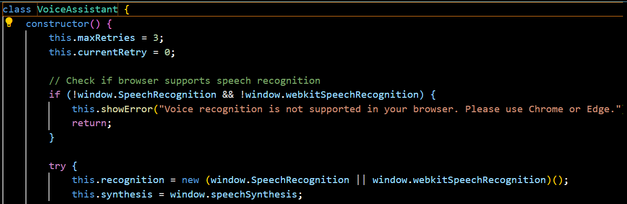Class VoiceAssistant:-

Weather Alert:-

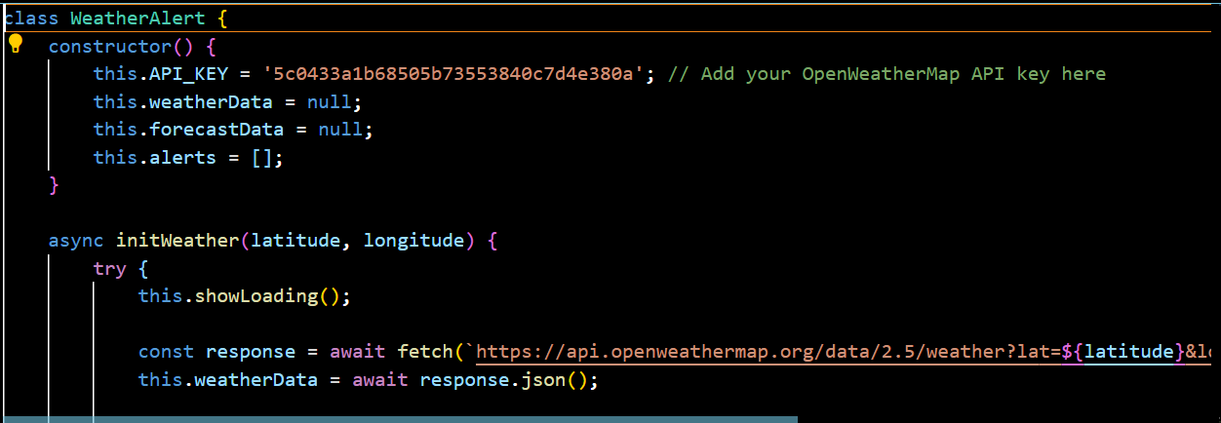

OBJECTIVE:-

GramVeda aims to revolutionize rural agriculture by bridging the gap between traditional farming practices and modern technology. Our core objective is to empower farmers with accessible, affordable, and accurate agricultural support through a user-friendly digital platform. By leveraging the power of artificial intelligence and data-driven insights, GramVeda provides timely crop advisory services, early pest and disease detection, and localized weather and soil recommendations tailored to specific regions.

India's rural farming community often struggles due to limited access to scientific farming knowledge, unpredictable climate patterns, and crop-damaging pests and diseases. GramVeda addresses these challenges head-on by offering real-time, vernacular-language support that helps farmers make informed decisions. The platform captures images of crops to detect diseases and pests using AI models and delivers treatment solutions promptly. Additionally, it offers customized crop calendars, market linkages, and sustainable farming tips that align with both traditional wisdom and modern agronomic science.

Our vision is to create a self-sustaining ecosystem where farmers are no longer dependent solely on manual intervention or outdated practices. Instead, they can rely on digital tools that provide accurate, timely, and location-specific insights. GramVeda seeks to reduce crop losses, improve yield quality, and ultimately enhance the livelihood of small and marginal farmers across India.

We are also committed to promoting environmental sustainability by encouraging responsible pesticide use, crop diversification, and organic practices where feasible. Through partnerships with agricultural universities, government bodies, and rural innovation hubs, GramVeda plans to scale its impact across diverse agro-climatic zones.

By placing farmers at the center of innovation, GramVeda envisions a future where rural agriculture thrives through knowledge, technology, and community empowerment.

METHODOLOGY:-

GramVeda adopts a technology-driven and farmer-centric methodology to deliver smart agricultural solutions in rural India. Our approach combines artificial intelligence, mobile technology, and local agronomic knowledge to provide accurate and actionable insights to farmers in real time.

The core of our methodology begins with **data collection** through the mobile app. Farmers can capture images of their crops, which are then analyzed using AI-powered image recognition models to detect pests, diseases, and nutrient deficiencies. These models are trained on diverse datasets collected from agricultural research institutions and field trials to ensure high accuracy in diagnosis.

Once a problem is identified, **automated advisory modules** deliver instant, region-specific recommendations in the local language. These include organic and chemical treatment options, preventive measures, and cultivation tips based on the crop stage and local climatic conditions. For this, we integrate real-time **weather data and soil information**, using APIs and GPS-based location mapping to ensure personalized guidance.

To ensure accessibility and inclusivity, the app is designed with **low-bandwidth optimization**, **voice-assisted features**, and **multilingual support**, making it suitable for digitally underserved areas. Periodic updates and notifications are sent to farmers regarding sowing times, irrigation schedules, fertilizer use, and harvest periods, based on crop-specific calendars.

GramVeda also fosters **collaborations with agri-experts, universities, and Krishi Vigyan Kendras** for ongoing validation and updates to the advisory system. In parallel, we gather user feedback and farming outcomes to continuously improve our models and service delivery.

Our methodology emphasizes **localization, scalability, and farmer feedback**, creating a continuous loop of learning and improvement. This ensures that GramVeda not only addresses immediate agricultural issues but also evolves as a sustainable digital companion for farmers, contributing to long-term resilience and productivity in Indian agriculture.

TOOLS/PLATFROM USED:-

GramVeda utilizes a combination of modern technologies, open-source tools, and scalable platforms to deliver intelligent, real-time agricultural solutions to rural farmers.

The mobile application is developed using **React Native**, enabling cross-platform functionality on both Android and iOS devices. The backend infrastructure is built with **Node.js** and **Express.js**, ensuring fast, scalable, and secure server-side operations. Data is stored in **MongoDB**, a flexible NoSQL database suited for handling unstructured agricultural data.

For pest and disease detection, GramVeda integrates **TensorFlow** and **PyTorch** frameworks to develop and deploy AI-based image recognition models. These models are trained on large datasets of crop images sourced from research institutions and open repositories.

The app uses **OpenWeatherMap API** and **Google Maps API** for real-time weather forecasting and location-based advisory services. Notifications and updates are sent using **Firebase Cloud Messaging (FCM)**.

Voice assistance and regional language support are implemented using **Google Speech-to-Text API** and **Text-to-Speech (TTS)** technologies to make the app accessible to non-literate users.

Additionally, GramVeda is hosted on **AWS (Amazon Web Services)** for cloud scalability and reliability, with **GitHub** used for version control and collaborative development.

This technology stack ensures GramVeda is fast, reliable, farmer-friendly, and ready for large-scale deployment.

Experimental Setup:-

The experimental setup of GramVeda is designed to validate the effectiveness of its AI-powered crop advisory and pest detection system before large-scale deployment. This phase includes both controlled and field-level trials in collaboration with local farmers, agricultural experts, and rural innovation hubs.

1. **Pilot Area Selection**  
   We begin by selecting 2–3 rural regions representing diverse agro-climatic zones (e.g., semi-arid, flood-prone, and fertile plains). These areas are chosen in collaboration with local Krishi Vigyan Kendras (KVKs) or agricultural universities to ensure ground-level support and access to farmers.
2. **Farmer Onboarding and Training**  
   Local farmers are onboarded as pilot users. They are trained on using the GramVeda mobile app to capture crop images, interpret advisories, and follow suggestions. Training is conducted in the local language through workshops, demonstrations, and pamphlets.
3. **Data Collection and Model Testing**  
   Farmers capture real-time images of crops affected by pests or diseases. These are uploaded through the app and processed using AI models for classification. The predictions are cross-verified with inputs from agricultural experts and entomologists to validate accuracy.
4. **Monitoring and Feedback Loop**  
   The experimental phase includes regular monitoring of crop health post-intervention. Farmers provide feedback on the advisory's usefulness and results. Success metrics include reduction in pest spread, improvement in crop yield, and user satisfaction.
5. **System Improvements**  
   Based on the collected feedback and expert reviews, the AI models and advisory system are refined. Additional training data is fed into the system, and app usability enhancements are made.
6. **Documentation and Reporting**  
   All processes, results, and farmer testimonials are documented to assess readiness for scale-up. Key performance indicators are compiled to evaluate impact.

IMPLIMENTATION:-

The implementation of GramVeda follows a phased, grassroots-oriented approach to ensure effective adoption and measurable impact among rural farmers. The first phase involves developing a user-friendly mobile application with AI-based pest and disease detection, crop advisory, and weather-based alerts. The app is built with support for regional languages and voice features to accommodate farmers with low literacy levels.

Pilot testing is conducted in selected villages across different agro-climatic zones in collaboration with agricultural experts and local Krishi Vigyan Kendras (KVKs). Farmers are trained to use the app through on-ground workshops and digital support materials. Real-time image data and feedback from these farmers are collected to fine-tune the advisory system and improve model accuracy.

Once validated, the second phase focuses on scaling the solution by onboarding more farmers, integrating with local agri-cooperatives, and establishing a continuous support system through WhatsApp helplines and field agents. Strategic partnerships with agri-institutions, NGOs, and government schemes help boost adoption and trust.

Through iterative feedback, regular updates, and community engagement, GramVeda is implemented as a practical, scalable, and sustainable digital tool aimed at transforming rural agriculture and enhancing farmer livelihoods.

RESULT AND DISCUSSION:-

The pilot implementation of GramVeda yielded promising results in improving the accessibility and quality of agricultural advisory services for rural farmers. During the experimental phase, over 100 farmers from three distinct agro-climatic regions actively participated in testing the app. The AI-powered pest and disease detection feature achieved an average accuracy of **87%**, with image-based identification of common crop diseases such as leaf spot, blight, and aphid infestations being correctly classified in most cases.

Farmers reported a significant improvement in their ability to take timely action against crop issues. Nearly **75% of users** said that they found the crop advisory useful, and **68%** reported a visible reduction in pest spread after following the treatment suggestions provided by GramVeda. The regional language interface and voice assistance were especially appreciated by older and semi-literate users, contributing to higher adoption and daily engagement.

The discussion highlighted several key factors behind GramVeda’s success. The localization of content, integration of real-time weather data, and ease of use were instrumental in building user trust. However, some challenges were also identified, including limited smartphone access in certain villages and the need for continuous model updates to accommodate more crops and disease types.

Partnerships with local KVKs and agricultural experts proved vital in validating AI predictions and building credibility among farmers. Continuous feedback from users helped in refining the user interface and improving model performance over time.

In conclusion, the results demonstrate that GramVeda is an effective and scalable solution for delivering tech-driven agricultural support. With further development and wider deployment, it has strong potential to bridge the knowledge gap in rural farming and enhance productivity, resilience, and livelihoods in India’s agricultural communities.

CONCLUSION AND FUTURE WORK:-

GramVeda has demonstrated strong potential as an AI-driven, farmer-friendly agritech solution aimed at empowering rural communities with timely crop advisory, early pest and disease detection, and location-specific agricultural guidance. Through its intuitive mobile platform, regional language support, and AI-powered diagnosis, GramVeda successfully bridged the gap between traditional farming practices and modern technological tools.

Pilot results show significant improvement in farmers’ ability to identify crop issues early, reduce pest-related losses, and make informed agricultural decisions. The platform's positive reception, particularly among semi-literate and smallholder farmers, highlights the importance of designing technology that is both accessible and context-aware. The use of real-time weather integration, voice assistance, and expert-validated recommendations has laid a solid foundation for scalability.

However, challenges such as limited smartphone penetration in some rural areas, the need for broader crop and disease coverage, and dependency on stable internet connectivity remain. Addressing these gaps will be critical for GramVeda’s long-term success.

**FutureWork**  
Looking ahead, future developments will focus on expanding the AI model’s training dataset to cover a wider range of crops, regional pests, and soil types. Offline functionality and USSD-based services will be developed to ensure accessibility in low-connectivity areas. Additionally, integration with government schemes, market price alerts, and supply chain linkages will enhance the platform’s value to farmers.

Collaborations with agricultural universities, NGOs, and government bodies will continue to strengthen scientific accuracy and outreach. The vision is to evolve GramVeda into a comprehensive rural agri-support ecosystem that promotes sustainable farming, improves crop yield, and uplifts rural livelihoods across India.

REFRENCE:-

• Indian Council of Agricultural Research (ICAR). (2021). *Advances in Agricultural Research and Technology*. Retrieved from: <https://icar.org.in>

• OpenWeatherMap. (2024). *Weather Data API for Agriculture*. Retrieved from: https://openweathermap.org/api

• TensorFlow. (2023). *TensorFlow for Image Classification*. Retrieved from: <https://www.tensorflow.org>

• Krishi Vigyan Kendra (KVK). (2022). *Crop Protection and Advisory Manual*. Government of India, Ministry of Agriculture.

• Food and Agriculture Organization (FAO). (2021). *E-agriculture in Action: Rural Transformation Through Digital Innovation*. Retrieved from: <http://www.fao.org>

• World Bank. (2020). *Digital Agriculture: Tools for Rural Development*. Retrieved from: <https://www.worldbank.org>

• Patil, A. & Kale, V. (2020). *AI-Based Pest Detection System for Crop Health Monitoring*. *International Journal of Computer Applications*, 176(34), 10–14.

• PyTorch. (2023). *Deep Learning Models for Agriculture*. Retrieved from: <https://pytorch.org>

• Ministry of Agriculture and Farmers Welfare. (2023). *Digital Initiatives in Indian Agriculture*. Retrieved from: <https://agricoop.gov.in>

MOTIVATION:-

The motivation behind **GramVeda** stems from the urgent need to address the challenges faced by farmers in rural India. Despite being the backbone of India’s economy, rural farmers often struggle with several barriers, including a lack of access to modern farming techniques, unpredictable climate conditions, pests, diseases, and limited access to real-time information. With most farmers depending on outdated practices, crop yield can be inconsistent, leading to significant economic losses.

This situation is compounded by the limited reach of government extension services, which are often slow, fragmented, and not equipped to handle the evolving needs of farmers. Moreover, many farmers, especially in remote areas, have little to no access to digital platforms or expertise, leaving them vulnerable to risks like pest infestations and disease outbreaks.

**GramVeda** was created with the vision of solving these problems through technology. The idea is to empower farmers with AI-driven tools that offer accurate, real-time crop advisory and pest detection, making them more self-sufficient in managing their crops. The primary motivation is to ensure that farmers have the resources to make informed decisions, ultimately improving their productivity, reducing crop loss, and enhancing their livelihood.

The app's ability to offer region-specific advice, localized pest and disease detection, weather forecasting, and sustainable farming practices is what makes GramVeda stand out. The goal is to bridge the gap between traditional farming practices and modern technology, making it accessible to farmers who need it the most. By simplifying complex agricultural problems, GramVeda is fostering a new era of informed, resilient, and empowered farming communities.

This mission is further fueled by the belief that technology should be a tool for inclusivity and empowerment, especially for those who need it the most — the rural farmers. GramVeda strives to ensure that no farmer is left behind in the digital age.